# CSS Guide – Shawn Rae

Overall Color scheme (Inspiration is Lavenders which can be seen attached in the photo below):

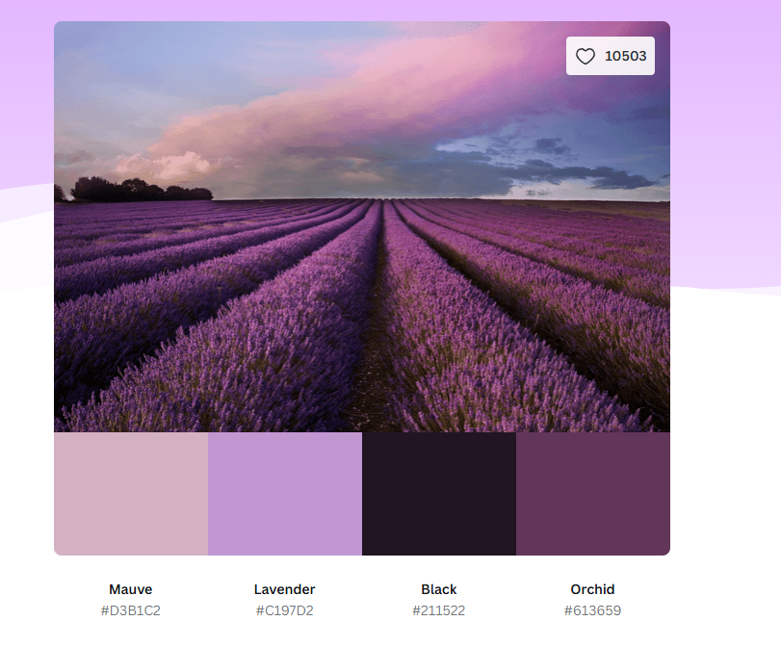

Background Color: rgb(193, 151, 210)

Main paragraph text color: Black

Headers: White

Navigation Bar:

* Set to the top of the screen
* Color: rgb(33, 21, 34)
* When Elements are hovered: rgb(211, 177, 194)

Hyper-links: White

* When Hovered: rgb(211, 177, 194)

General styling:

Font – Serif Garamond

Font size:

* Header – 3vw
* Body text and link – 1vw

Padding – 15 px

Images being used:

Lavender_Field.jpg – Photo of a Lavender field taken from pixabay <https://pixabay.com/photos/lavender-lavender-field-france-4777780/>